NOTE: Instructions are included in red italics. Please delete all instructions before printing out your final plan.

[Company Logo]
(if applicable)

[Company Name] BUSINESS PLAN
[Current Month], [Year]

[Name]
[Title]
[Company Name]
[Address 1]
[Address 2]
[City, State Zip]
Tel: [ ]
Fax: [ ]
Email: [ ]

CONFIDENTIAL

No offering is made or intended by this document. Any offering of interests in [Company Name] will be made only in compliance with Federal and State securities laws.

This document includes confidential and proprietary information of and regarding [Company Name]. This document is provided for informational purposes only. You may not use this document except for informational purposes, and you may not reproduce this document in whole or in part, or divulge any of its contents without the prior written consent of [Company Name]. By accepting this document, you agree to be bound by these restrictions and limitations.

Table of Contents
(Right click anywhere on this table and select Update Field before printing your plan)

I. Executive Summary 1
II. Company Overview 3
III. Industry Analysis 4
Market Overview 4
Relevant Market Size 5
IV. Customer Analysis 6
Target Customers 6
Customer Needs 7
V. Competitive Analysis 8
Direct Competitors 8
Indirect Competitors 9
Competitive Advantages 10
VI. Marketing Plan 12
Products, Services & Pricing 12
Promotions Plan 13
Distribution Plan 14
VII. Operations Plan 15
Key Operational Processes 15
Milestones 16
VIII. Management Team 18
Management Team Members 18
Management Team Gaps 19
Board Members 19
IX. Financial Plan 21
Revenue Model 21
Financial Highlights 21
Funding Requirements/Use of Funds 23
Exit Strategy 23
X. Appendix 24

I. Executive Summary

SUGGESTION: Complete your Executive Summary LAST. It is easier to do once the other sections of your plan are done.
Business Overview

Start with a CONCISE one to two line explanation of your business such as:
- We are an organic restaurant located in Miami, FL
- We operate a social networking website for working mothers
- We are a software development company that enables individuals to more efficiently complete their taxes

If you need help doing this, try one or more of the following exercises:

[Company Name] __________________ (what you do, e.g., helps, provides, sells, manufactures, etc.) __________________ (what you offer, etc., food, services, software, etc.) to __________________ (who your customers are, e.g., teenagers, new parents, business managers) with the following benefits __________________ (list benefits, e.g., faster, more reliable, lower cost).

OR

Do you know how __________________ (insert problem, etc., it’s hard to stay on a diet), what our company does is __________________ (insert your solution, etc., helps people stay on diet by doing this and that).

OR

We are like ___________________ (well known company that is similar to yours) except that we ___________________ (how you are different/better). (e.g., We are like Domino’s Pizza except that we use higher quality ingredients which make our products taste better than theirs).

Success Factors
[Company Name] is uniquely qualified to succeed due to the following reasons:

List as many reasons you can think of regarding why your company will succeed. Below are several examples/areas you can choose from. Add specific examples to the bullets that work for your business, and delete ones that are not relevant.

- Products and/or Services: Our Products and/or Services are superior to our competitors because
- Human Resources: Our management team has unique experience in the industry including
- Location: Our location allows us to better serve customers because
- Operational Systems: We have developed systems that enable us to provide high quality products/services at a lower cost. These systems include
- Intellectual Property (IP): We have Intellectual Property that gives us an advantage over our competitors. Our IP includes
- Customers: We are already serving key customers which our competitors are not. These customers include
- Marketing: We have unique marketing skill sets that enable us to attract new customers at a low cost These skill sets include
- Successes achieved to date: We have already accomplished the following which positions us for future success.

Financial Plan

Below is an overview of our expected financial performance over the next five years:

To achieve these projections, we need to raise $___________ in financing.

Figure 1: Annual Financial Summary
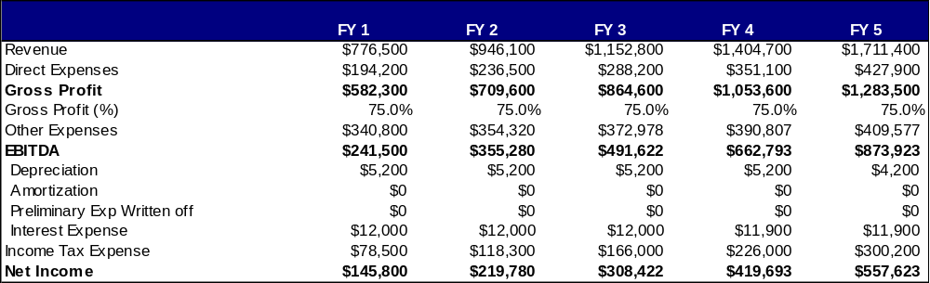

II. Company Overview

Below is a snapshot of [Company Name] since its inception:

Below are several variables. For the relevant variables, add the details for your company (e.g., C-Corporation). Delete those that are not relevant.

- Date of formation:
- Legal structure (LLC vs. C-Corp., etc.):
- Office location(s):
- Business stage (start-up vs. undergoing R&D vs. serving customers, etc.):
- Prior funding rounds were received (amount/date):
- Products and services were launched (names/dates):
- Revenue milestones were reached (e.g., date when sales surpassed $X):
- Key partnerships were executed (names/dates):
- Key customer contracts were secured (names/dates):
- Key employees were hired (names/dates):
- Other key events:
- Other key events:
- Other key events:
- Other key events:
- Other key events:

III. Industry Analysis

Market Overview
The market in which [Company Name] is operating can be characterized by the following:

You can easily find the following information in one of two ways:

- Find an association in your industry (go to a search engine and type in “[your industry name] association” (e.g., “restaurant association”), find your association and then search the association’s website for research they’ve conducted on your industry.
- Go to a search engine and type in “[your industry name] market size” (e.g., “restaurant industry market size”), and review the results.

For example, the following statistics were taken from the National Restaurant Association’s website:

- Restaurant Market
- Sales: $580 billion
- Locations: 945,000
- Employees: 12.7 million — one of the largest private-sector employers
- Restaurant-industry share of the food dollar: 49%
- $1.6 billion: Restaurant-industry sales on a typical day.
- $2,698: Average household expenditure for food away from home in 2008.
- 73 percent of adults say they try to eat healthier now at restaurants than they did two years ago.
- Etc.

- Industry Sales ($):
- Industry Sales (units):
- Other Key Statistics:

- Market trend 1 (e.g., growth/decline):
- Market trend 2 (e.g., changing customer needs):

Relevant Market Size
Our relevant market size is the annual revenue that our company could attain if we owned 100% market share.

Our relevant market size is calculated as follows:

- Number of customers who might be interested in purchasing our products and/or services each year?
- Amount these customers might be willing to spend, on an annual basis, on our products and/or services? $
- Our relevant market size (#1 X #2):

As the analysis shows, our relevant market is large enough for our company to enjoy considerable success.

IV. Customer Analysis

Below is a description of who our target customers are, and their core needs.

Target Customers
Below is a profile of our target customers:

Below are several demographic (e.g., age) and psychographic (e.g., values) variables. For the relevant variables, add the details for your target customers (e.g., age 18-24). Delete those that are not relevant.
- Age:
- Income:
- Gender:
- Location:
- Marital status:
- Family size:
- Occupation:
- Language:
- Education:
- Values/Beliefs:
- Activities & Interests:
- Business size:

Below is a snapshot of the size of our target customer market:

- To find this information, go to http://www.zipskinny.com/ (for demographic statistics by zip code) and/or http://www.bls.gov (for number of businesses fitting your target customer profile).

Customer Needs

Below is a profile of the needs that our target customers have:

Here you will specify why customers want or need your products and/or services. Below are several examples and customer need areas. For the relevant areas, modify to detail the needs of your customers (e.g., customers want products that work faster). Feel free to add to or delete from these customer needs.

- Speed:
- Quality:
- Location:
- Reliability:
- Comfort:
- Price:
- Value:
- Customer Service:
- Convenience:
- Ease of use:
- Other:
- Other:
- Other:
- Other:

V. Competitive Analysis

The following is an overview of [Company Name’s] competitors.

Notes for completing this section of your business plan:
- Any company or action that serves your customer’s needs is a competitor to you
- There are Direct and Indirect competitors. Here are examples for a pizza shop:
  - Direct competitors (fills customer need with same solution)
    - Other pizza shops
  - Indirect competitors (fills customer need with different solution):
    - Other restaurants
    - Supermarkets selling frozen or ready-to-bake pizza

Direct Competitors

Complete the information for each of your direct competitors. Feel free to add to or delete fields as appropriate (e.g., if you don’t know your competitors’ revenues).

The following companies are our direct competitors.
- Direct Competitor #1:
- Products/services offered:
- Price points:
- Revenues (# units sold/dollars generated):
- Location(s):
- Customer segments/geographies served:
- Competitor’s key strengths:
- Competitor’s key weaknesses:

- Direct Competitor #2:
- Products/services offered:
- Price points:
- Revenues (# units sold/dollars generated):
- Location(s):
- Customer segments/geographies served:
- Competitor’s key strengths:
- Competitor’s key weaknesses:

- Direct Competitor #3:
- Products/services offered:
- Price points:
- Revenues (# units sold/dollars generated):
- Location(s):
- Customer segments/geographies served:
- Competitor’s key strengths:
- Competitor’s key weaknesses:

Indirect Competitors

Complete the information for each of your indirect competitors. Feel free to add to or delete fields as appropriate (e.g., if you don’t know your competitors’ revenues). You can delete the entire “Indirect Competitors” section if you don’t feel it is relevant to your business.

The following companies are our indirect competitors.

- Indirect Competitor #1:
- Products/services offered:
- Price points:
- Revenues (# units sold/dollars generated):
- Location(s):
- Customer segments/geographies served:
- Competitor’s key strengths:
- Competitor’s key weaknesses:

- Indirect Competitor #2:
- Products/services offered:
- Price points:
- Revenues (# units sold/dollars generated):
- Location(s):
- Customer segments/geographies served:
- Competitor’s key strengths:
- Competitor’s key weaknesses:

Competitive Advantages

[Company name] is positioned to outperform competitors for the following reasons:

Like in the Executive Summary, list as many reasons you can think of regarding why your company will succeed. Below are several examples/areas you can choose from. Add specific examples to the bullets that work for your business, and delete ones that are not relevant.

- Products and/or Services: Our Products and/or Services are superior to our competitors because
- Human Resources: Our management team has unique experience in the industry including
- Location: Our location allows us to better serve customers because
- Operational Systems: We have developed systems that enable us to provide high quality products/services at a lower cost. These systems include
- Intellectual Property (IP): We have Intellectual Property that gives us an advantage over our competitors. Our IP includes
- Customers: We are already serving key customers which our competitors are not. These customers include
- Marketing: We have unique marketing skill sets that enable us to attract new customers at a low cost These skill sets include
- Successes achieved to date: We have already accomplished the following which positions us for future success.

VI. Marketing Plan

Our marketing plan, included below, details our products and/or services, pricing and promotions plans.

Products, Services & Pricing
For each of your key products, complete the following fields:
- Product/Service #1 Name:
- Product/Service description/features:
- Product/Service benefits:
- Product/Service price:
- Product/Service expected purchase frequency/quantity:
- Product/Service strengths:
- Product/Service weaknesses:

- Product/Service #2 Name:
- Product/Service description/features:
- Product/Service benefits:
- Product/Service price:
- Product/Service expected purchase frequency/quantity:
- Product/Service strengths:
- Product/Service weaknesses:

Promotions Plan

[Company Name] will use the following tactics to attract new customers:

For the tactics you do/will use, include relevant specifics (e.g., magazines you advertise in). Delete the tactics you do/will not use and add tactics that aren’t included.
- Blimps, Banners, and/or Billboards
- Blogs, Podcasts, etc.
- Catalogs
- Classified Ads
- Contests
- Coupons
- Direct Mail
- Door Hangers
- Email Marketing
- Event Marketing
- Flyers
- Gift Certificates
- Networking
- Newsletters
- Newspaper/Magazine/Journal ads
- Online Marketing
- Partnerships/Joint Ventures
- Postcards
- Press Releases/PR
- Radio Ads/TV Ads/Infomercials
- Telemarketing
- Trade Shows
- Word of Mouth / Viral Marketing
- Yellow Pages
- Other:
- Other:
- Other:

Distribution Plan

If you operate a retail store and/or an online store, and your storefront is the only way in which customers can buy from you, delete this section. If not, complete the question below. Add or delete distribution methods as applicable and include any details (e.g., names of distributors or partners).

Customers can buy from us via the following methods:
- Retail location:
- Company website:
- Direct mail catalog:
- Distributors:
- Other retailers:
- Partners:
- Other:
- Other:

VII. Operations Plan

Our Operations Plan details:

  - The key day-to-day processes that our business performs to serve our customers
  - The key business milestones that our company expects to accomplish as we grow

Key Operational Processes

The key day-to-day processes that our business performs to serve our customers are as follows:

Below are key operational functions that your business may need to fulfill. For functions that are relevant, leave them and add details (e.g., our manufacturing team produces our widgets; our customer service team ensures that all customer requests are handled). Delete operational functions that are not relevant to your business. Add relevant operational functions that are not included below.

- Product Development:
- Sales:
- Marketing:
- Finance:
- Customer Service:
- Manufacturing:
- Administration:
- Accounting/Payroll:
- Human Resources:
- Legal:
- Purchasing:
- Other:
- Other:
- Other:

Milestones

The key business milestones that our company expects to accomplish as we grow include the following:

In this section, you need to list the key milestones that you hope to achieve in the future and the target dates for achieving them. Sample milestones include:

- New products and services introductions
- Store opening date
- Revenue milestones (date when sales exceed $50K, when sales exceed $100K, etc.)
- Key partnerships executed
- Key customer contracts secured
- Key financial events (future funding rounds, IPO, etc.)
- Key employee hires

Include 1-3 accomplishments per date.

I. To Be Completed By: ________________ (include day, month, quarter and/or year)
Accomplishments:

- Accomplishment #1:
- Accomplishment #2:
- Accomplishment #3:

II. To Be Completed By: ________________ (include day, month, quarter and/or year)
Accomplishments:

- Accomplishment #1:
- Accomplishment #2:
- Accomplishment #3:

III. To Be Completed By: ________________ (include day, month, quarter and/or year)
Accomplishments:

- Accomplishment #1:
- Accomplishment #2:
- Accomplishment #3:

IV. To Be Completed By: ________________ (include day, month, quarter and/or year)
Accomplishments:

- Accomplishment #1:
- Accomplishment #2:
- Accomplishment #3:

V. To Be Completed By: ________________ (include day, month, quarter and/or year)
Accomplishments:

- Accomplishment #1:
- Accomplishment #2:
- Accomplishment #3:

VIII. Management Team

Our management team has the experience and expertise to successfully execute on our business plan.

Management Team Members

For each key person on your current team, including yourself, complete the information below. Delete educational background if not relevant (e.g., if not college degree or higher).

- Name:
- Title:
- Key Functional Areas Covered:
- Past positions, successes and/or unique qualities:
- Educational background:

- Name:
- Title:
- Key Functional Areas Covered:
- Past positions, successes and/or unique qualities:
- Educational background:

- Name:
- Title:
- Key Functional Areas Covered:
- Past positions, successes and/or unique qualities:
- Educational background:

- Name:
- Title:
- Key Functional Areas Covered:
- Past positions, successes and/or unique qualities:
- Educational background:

- Name:
- Title:
- Key Functional Areas Covered:
- Past positions, successes and/or unique qualities:
- Educational background:

Management Team Gaps

If your management team has gaps (key people you expect to hire in the future), include what position(s) is/are missing and who will fill the positions. Delete this section if not applicable.

- Title/Role:
- Key Functional Areas Covered:
- Qualities of the individual who will be sought to fill this role:

- Title/Role:
- Key Functional Areas Covered:
- Qualities of the individual who will be sought to fill this role:

- Title/Role:
- Key Functional Areas Covered:
- Qualities of the individual who will be sought to fill this role:

Board Members

If you have a Board of Directors or Board of Advisors, include the Board members below. If not, delete this section.

- Name:
- Past positions, successes and/or unique qualities:

- Name:
- Past positions, successes and/or unique qualities:

- Name:
- Past positions, successes and/or unique qualities:

- Name:
- Past positions, successes and/or unique qualities:

- Name:
- Past positions, successes and/or unique qualities:

IX. Financial Plan

Revenue Model

[Company Name] generates revenues via the following:

Include each of the ways in which your company generates revenues. Examples are below. Delete non-relevant bullets. Better define relevant bullets.

- Sales of products/services
- Referral revenues
- Advertising sales
- Licensing/royalty/commission fees
- Donations
- Other
- Other

Financial Highlights

Below please find and overview of our financial projections. See the Appendix for our full projected Income Statements, Balance Sheets and Cash Flow Statements.

Figure 2: Financial Highlights


Figure 3: Projected Expenses


Funding Requirements/Use of Funds

Fill in the blanks using figures from your financial model. For the primary uses of funding, only include the 3-5 biggest expense areas. The areas below (e.g., product development) are examples. Feel free to delete those and include your own.
To successfully execute on our business plan, we require $_____________ in outside funding.

The primary uses of this funding include:

- Product Development:
- Marketing:
- Product Manufacturing:
- Staffing:
- Rent:
- Other:
- Other:

Exit Strategy

Include this section if you are seeking equity capital. If not, delete this section.

We expect that investors will be able to cash out on their investment in our company when we ________________ (enter “are acquired” or “go public”). We expect to achieve this goal by ________________ (include expected month and year).

X. Appendix

The Appendix is used to support the rest of the business plan.

The following are other things you might want to include in the Appendix if they are relevant to your business:

- Technology: Technical drawings, patent information, etc.
- Product/Service Details: More details about your products and services (such as features and specifications, menus, store designs, etc.)
- Partnership and/or Customer Letters: Letters from partners and/or customers stating their interest in working with your company can add enormous credibility and validation.
- Expanded Competitor Reviews: if you want to include more information than you included in the Competition section above.
- Customer Lists: Including a list of key customers that your company is serving in addition to their status and/or type or quantity of product/service being sold.

The following items are included in this Appendix:

- Projected Income Statements
- Projected Balance Sheet
- Projected Cash Flow Statements

Figure 4: 5 Year Annual Income Statement

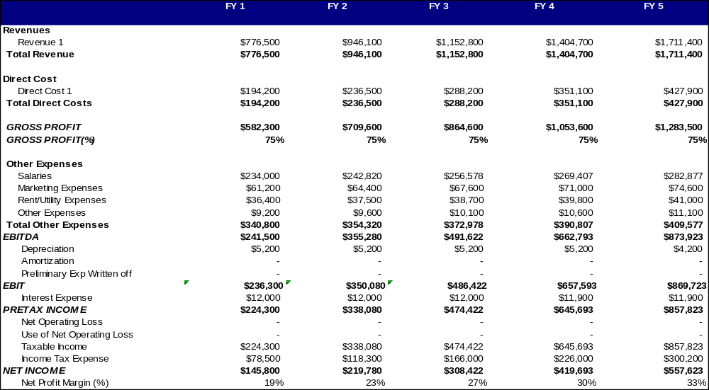
Figure 5: 5 Year Annual Balance Sheet
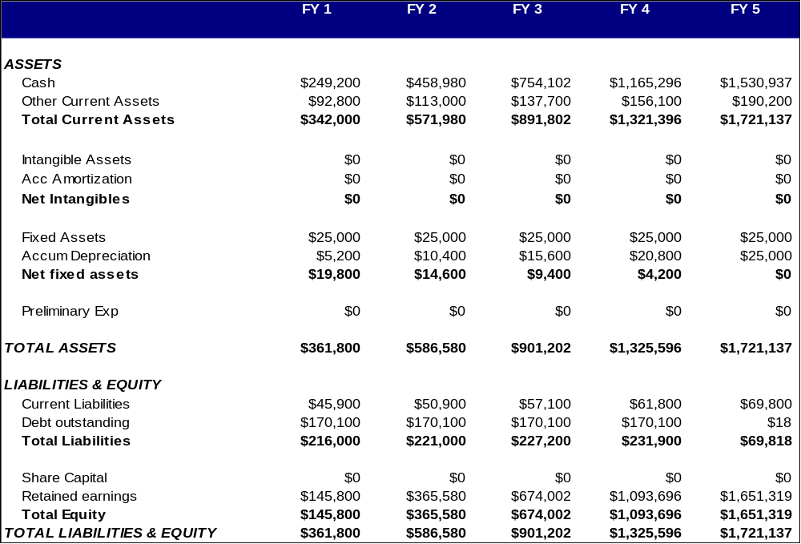

Figure 6: 5 Year Annual Cash Flow
